Read Aloud with Preschool
Here is a list of core books that we ‘read aloud’ to the children in Preschool These books have been carefully selected by the class teachers and include some of their own favourites.
Mrs Shurlock   | 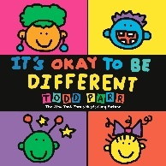  It’s ok to be different  By Todd Parr
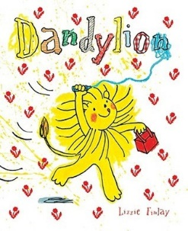
Dandylion
By Lizzie Finlay
Mrs Kadar   | 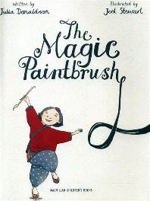  The Magic Paintbrush  By Julia Donaldson
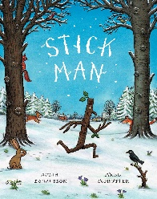

Stick Man
By Julia Donaldson

Mrs Shoplyak   | 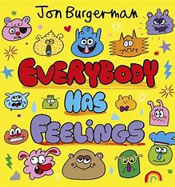  Everybody Has Feelings  By Jon Burgerman
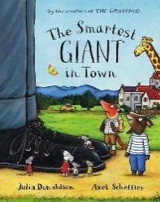
The Smartest Giant in Town
By Julia Donaldson

Read Aloud with Reception
Here is a list of core books that we ‘read aloud’ to the children in Reception. These books have been carefully selected by the class teachers and include some of their own favourites.
Mrs Eagle  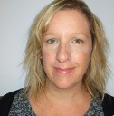 | 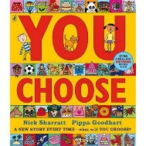  You Choose  By Pippa Goodhart
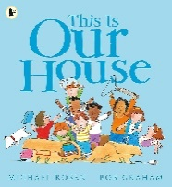
This is Our House
By Michael Rosen
Mrs Booth  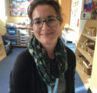 | 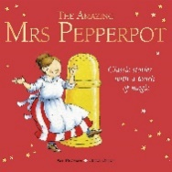  The Amazing Mrs Pepperpot  By Alf Prosen
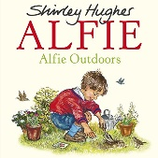
Alfie
By Shirley Hughes

Miss Adams  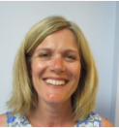 | 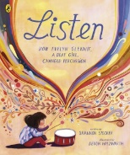  Listen  By Shannon Stocker
Mrs Wiltshire   | 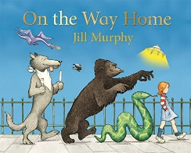  On the Way Home  by Jilly Murphy
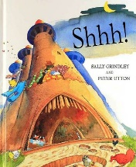
Shhh!
By Sally Grindley
Read Aloud with Year 1
Here is a list of core books that we ‘read aloud’ to the children in Year 1.
These books have been carefully selected by the class teachers and include some of their own favourites.
Mrs Shaw  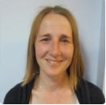 | 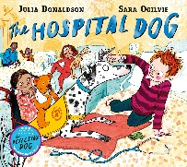  The Hospital Dog  By Julia Donaldson
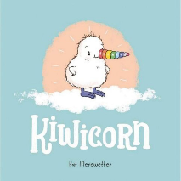
Kiwicorn
By Kat Merewether

Mrs DuToit  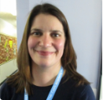 | 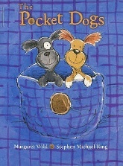  The Pocket Dogs  By Margaret Wild
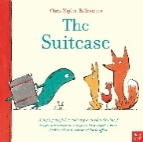
The Suitcase
By Chris Naylor-Ballesteros
Mrs Turner   | 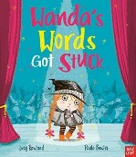  Wanda’s Words Got Stuck  By Lucy Rowland
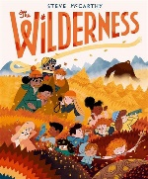
The Wilderness
By Steve McCarthy
Mrs Hyem   | 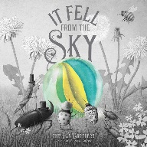  It Fell from the Sky  By The Fan Brothers
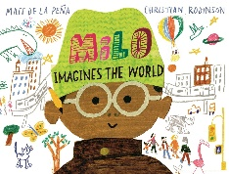
Milo Imagines the World
By Christian Robinson and Matt De La Pena
Read Aloud with Year 2
Here is a list of core books that we ‘read aloud’ to the children in Year 2. These books have been carefully selected by the class teachers and include some of their own favourites.
Mrs Smith   | 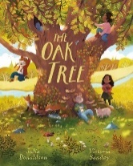  The Oak Tree  By Julia Donaldson
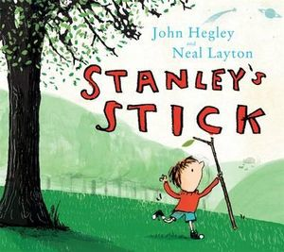
Stanley’s Stick
By John Hegley and Neal Layton

Mrs Beecher  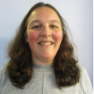 | 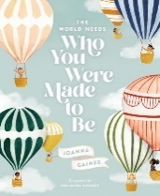  The World Needs Who You Were Made to Be  By Joanna Gaines
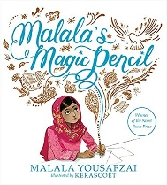
Malala’s Magic Pencil
By Malala Yousafzai

Mrs Rankin   | 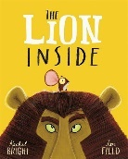  The Lion Inside  By Rachel Bright
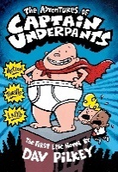
The Adventures of Captain Underpants
By Dav Pilkey
Mrs Richards   | 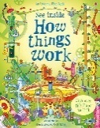  See Inside How Things Work  By Conrad Mason
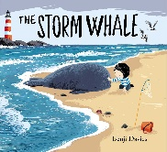
The Storm Whale
By Benjii Davies

